- Which is the most likely explanation for the presence of 13 different finch species on the Galápagos Islands today?
  - Many years ago several different species of birds migrated to the islands and the 13 finch species that currently live there are the only species that survived.
  - Many years ago a small population of a single bird species migrated to the islands and evolved into the 13 species that live on the islands today.
  - Each of the 13 species has migrated to the islands at different times over the years.
  - A single bird species migrated to one island at around the time of Charles Darwin’s voyage to the Galápagos and then migrated to all 13 islands.

- Different finch species have beaks of different shapes and sizes. These different beak structures are evidence of
  - different finch species adapting to different environments over many generations.
  - different finch species with different beak structures coming to the Galápagos Islands from the mainland.
  - different finch populations being evolutionarily related.
  - individual birds changing their beak characteristics so that they could feed efficiently.

- Examine the phylogenetic tree of the 13 finch species below.
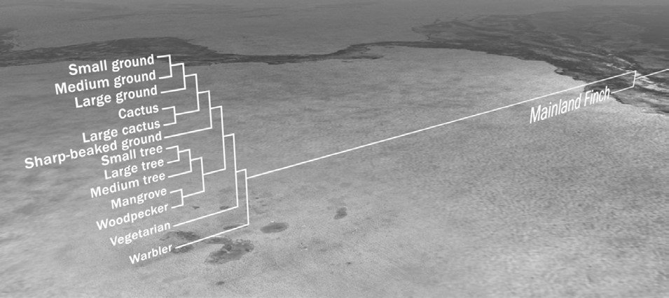
Which of the following statements is a correct interpretation of the phylogenetic tree in the illustration?
  - The sharp-beaked ground finch is more closely related to the small tree finch than either species is to the cactus finch.
  - The warbler finch is the common ancestor to all the finch species that exist today in the Galápagos Islands.
  - All the Galápagos finches are more closely related to one another than they are to mainland finch species.
  - The 13 finch species evolved in sequence; the warbler finch is the oldest species and the small ground finch is the most recent species to evolve.

- Which experimental data from the film provide the best evidence that the cactus finch and the medium ground finch on Daphne Major are distinct species?
  - Many more medium ground finches than cactus finches died in response to the drought.
  - Cactus finch and medium ground finch males attempted to breed only with females of their own species.
  - The cactus finch and medium ground finch feed on different types of food.
  - Medium ground finch and cactus finch females have different markings and feather color.

- Imagine you are studying a population of finches on one of the Galápagos Islands. You have been recording many of the birds’ physical traits, including the length of both wings. You observe that for 80% of individuals measured, the length of the left wing is not significantly different from the length of the right wing (in other words, they are symmetrical). But for about 20% of birds measured the wing lengths are asymmetrical. This distribution is true from generation to generation. Suddenly, a rare 5-day windstorm takes over the island. After the storm, you spend the next several days netting each bird on the island that survived the storm. You discover that 85% of the birds with symmetrical wings survived the storm, whereas only 5% of the birds with asymmetrical wings did.

  - Propose a hypothesis to explain this observation.

  - If such storms become increasingly common due to changes in climate, how might you expect the population to change over time with respect to wing symmetry?

- Which statement or statements describes geographically isolated populations? (Read the five statements below and then select the appropriate answer, a–d.)
- The two populations live on different islands.
- One population breeds in late spring and the other population breeds in late summer.
iii.One population eats mostly small, soft seeds and the other population eats mostly large, hard seeds.
iv. The males of one population have different mating calls than the males of the other population.
v. The females of the two populations look the same.
  - statement i only
  - statements i and iv only
  - statements ii, iii, and v only
  - statement iv only

- How did the Grants test their hypothesis that differences in birds’ songs can keep different species of finches from breeding with each other?
  - They watched which birds were mating with each other and listened for the songs the birds were singing.
  - They recorded birds singing on the island of Daphne Major for an entire breeding season to see which type of song was used more often by each species.
  - They played the songs of medium ground finches and cactus finches through a loudspeaker at different times, when individuals from both species were present, to see which species responded to each song.
  - They played the song of the medium ground finch to medium ground finch males through a loudspeaker to see if they would respond; they then played the song of the cactus finch to cactus finch males to see if they would respond.

- Explain the evidence presented in the film for your answer in question #7 above.
  - Males only came to the loudspeaker when the song of their own species was being played.
  - The type of song used more often during the breeding season was also the song sung by the most abundant species.
  - During mating, the birds were singing the songs of their own species.

- Figure 1 shows the beak depths of 200 medium ground finches on Daphne Major before a severe drought began on the island. This is a normal sample of a population of medium ground finches, similar to measured samples from previous years. During wet years, all types of seeds are abundant. The medium ground finch prefers to eat small, soft seeds that are easy to crush. However, during droughts, when small seeds are not as abundant, they also eat the larger seeds on the island.

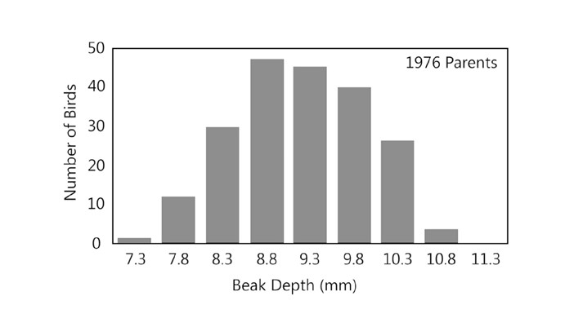
Figure 1. Beak sizes of a sample of 200 medium ground finches living in Daphne Major in 1976.
  - Make two or three observations about the distribution of beak depth measurements in this sample of 200 medium ground finches?

  - What is the most common beak depth of the finches living in Daphne Major in 1976? ______________
  - What is the range of beak depths in this group of medium ground finches? ________________

- Figure 2 shows the same graph as in Figure 1 but with the birds that survived the drought shown by black bars.

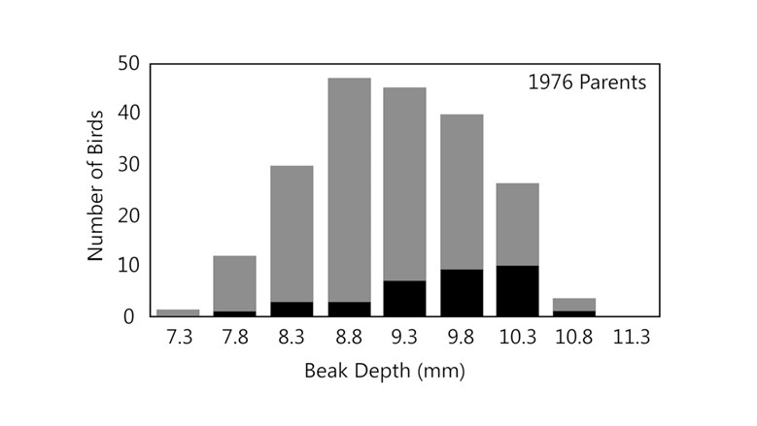
Figure 2. Beak sizes of medium ground finches living in Daphne Major in 1976 (red bars) and of the finches that survived the drought of 1977 (black bars).

  - Approximately what percentage of birds with the most common beak depth in 1976 (your answer to question #9 b) survived the drought? (Show your work)

  - Compare the original group of medium ground finches (red bars) to the group of survivors (black bars). List two observations you can make based on the data provided in the graph. Consider both the number of birds and beak characteristics.

  - Provide one possible explanation for the change in bird numbers and beak characteristics.

- The graph in Figure 3 represents the beak sizes of the offspring of the birds that survived the drought of 1977. (The survivors were represented by the black bars in Figure 2, and this graph shows the beak depth distribution of their offspring in 1978.)

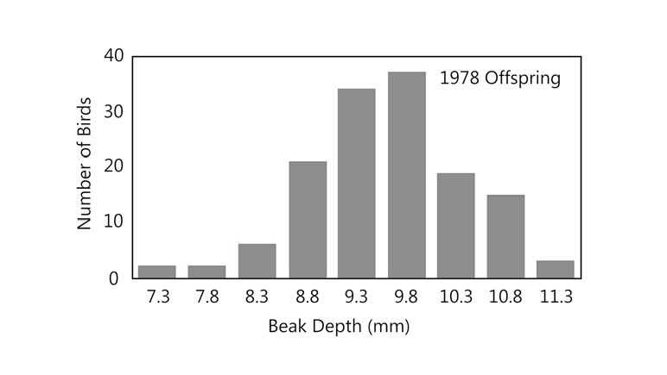
Figure 3. Beak sizes of the offspring of the medium ground finches that survived the drought of 1977.

Identify and describe similarities and differences between this group of medium ground finches an the following groups: a. the sample of 200 medium ground finches measured in 1976 (Figure 1).

b. the sample of medium ground finches that survived the drought of 1977 (Figure 2 black bars).

- Explain the observed change in beak characteristics using the following concepts in your answer: competition, survival of the fittest, inheritance.

