Grants’ Finch Study Data
Figure 1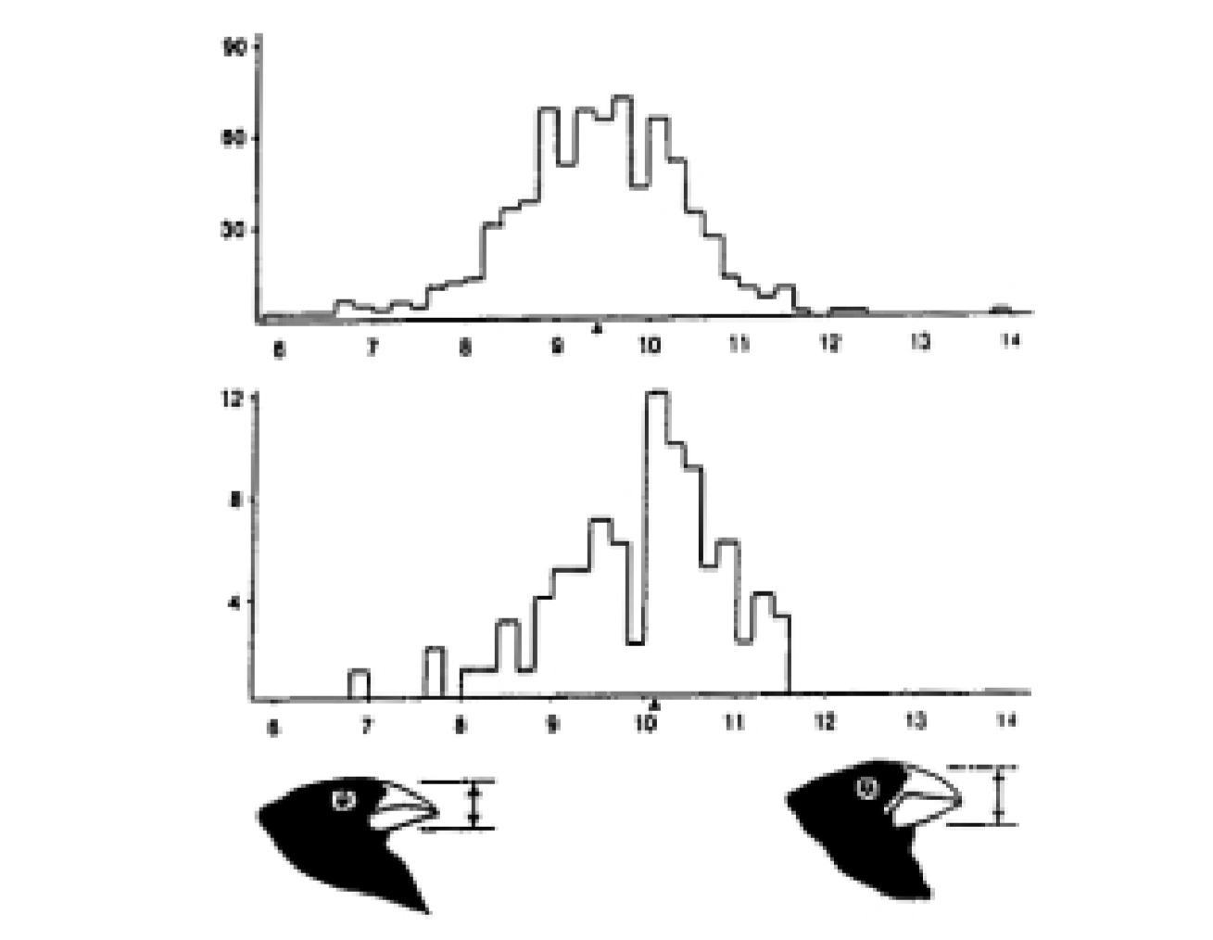
1976
All Daphne Birds
N
= 751
1978
Survivors
N
=

90
Beak Depth (mm)
Number of Finches
Number of Finches
Figure 1: Histogram of distribution of beak depth of medium ground finches (Geospiza fortis) on Daphne Major, before and after the drought of 1977 (Grant 1986). Reprinted by permission of Princeton University Press.
Figure 2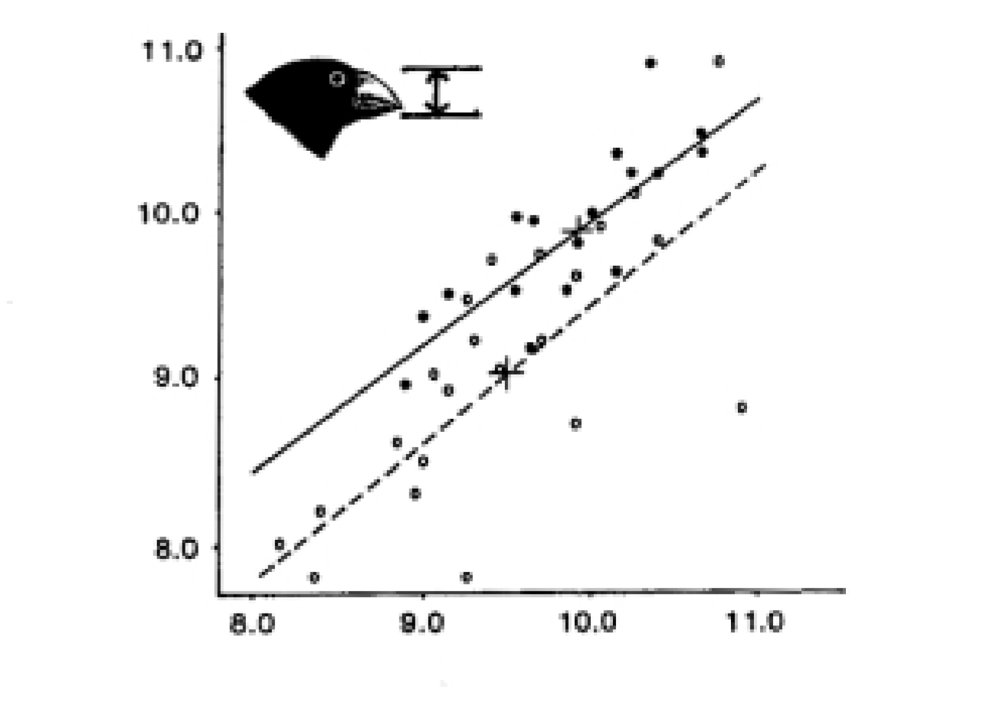
Offspring Bill Depth (mm)
Midparent Bill Depth (mm)
°=1976 population and •=1978 population
Figure 2: Relationship between beak depth of offspring and their parents in the medium ground finch (Geospiza fortis) population on Daphne Major. The slope of the relationship is the heritability (Boag 1983).
1
©2001 WGBH Educational Foundation and Clear Blue Sky Productions, Inc. All rights reserved.
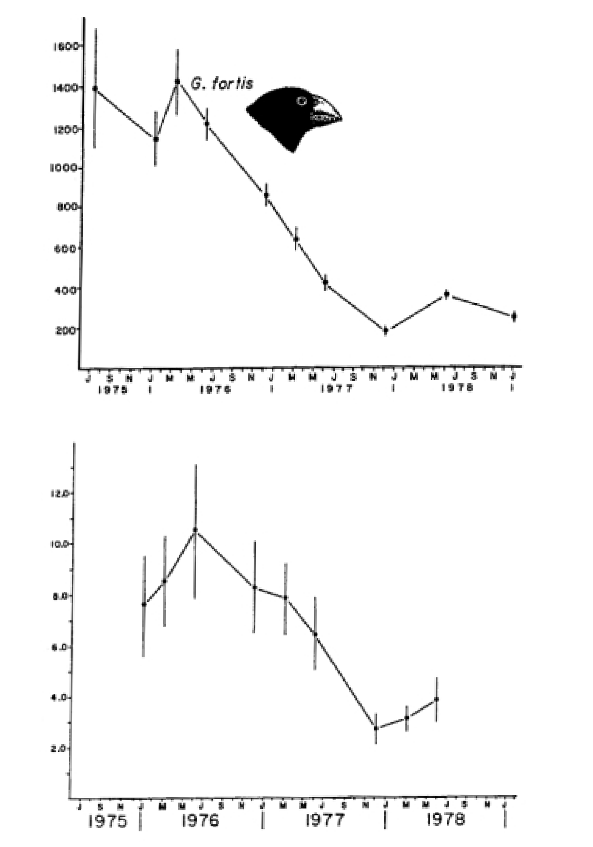
Figure 3
A
B
Population Size
Seed Abundance
(
g/m
2
)
Estimates ±95%
Confidence Limits
Daphne. All Edible Species x±s.e.
Figure 3: Changes in Geospiza fortis population and seed abundance on Daphne major, before and after the drought of 1977 (Grant 1986).
2
©2001 WGBH Educational Foundation and Clear Blue Sky Productions, Inc. All rights reserved.

