DNA Structure and Function
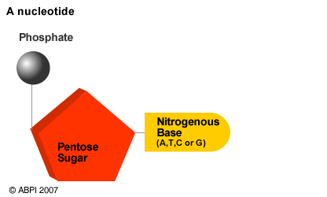
DNA Structure
DNA is composed of units called ____________________________, which
are composed of ________________ sub-molecules
- ___________________________ (deoxyribose)
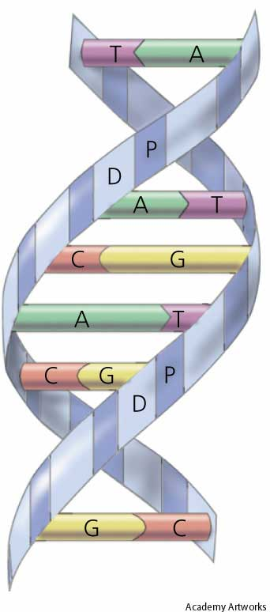
- ______________________
- ___________________________ (Adenine, thymine, cytosine or guanine)

DNA is composed of two _______________________ strands of _________________ joined together by ____________________________________________.
_______________ pairs with __________________ (A-T or T-A)
_______________ pairs with __________________ (C-G or G-C)
DNA twists into a __________________________________.
Packing of DNA in the Cell
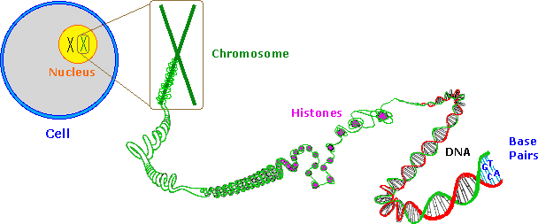

Functions of DNA
- DNA __________________________ the machinery of the cell to make specific ______________________, and therefore, DNA indirectly controls all of the functioning of all living things
- DNA stores the _________________________________________ of an individual.
- DNA has the ability to _________________________ (change). This allows for new characteristics and abilities to appear which may help an individual to survive and reproduce (____________________)
- Self-replication: DNA bas the ability to ____________________________________

DNA Replication
- DNA replication I called “_______________________________________”.
- Semi-conservative replication is the process in which the ____________________________ of DNA ______________________________________________ and act as ________________________ for the synthesis of duplicate strands of DNA.
- One copy of a DNA molecule will split apart to make ______________ complete copies of itself. Each new DNA molecule is made up of _______________________________ molecule and _________________________ molecule.
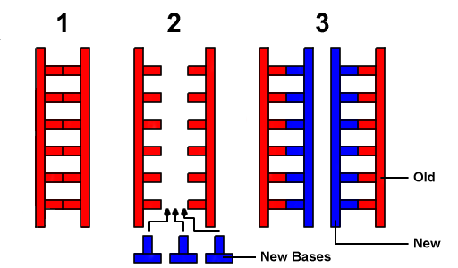

Steps to DNA Replication
- ____________________: The DNA molecule “unzips” as the ________________________ between base pairs are _____________________. The enzyme _________________ causes this unzipping to occur.
- ________________________________________: complementary _________________ move into position to bond with the complementary bases on the DNA chain.
- Form NEW _____________________ _____________________ backbone: The nucleotides join as the sugars and phosphates bond to form a new backbone. This process occurs due to the enzyme ___________________________________ which also checks for ___________________ as it goes.
- This process continues along the primary chain until we have _______________________________________ of DNA molecules (assuming there have been no errors made).
