Protein Synthesis
Proteins have 2 main functions:
- _________________: Proteins help make up all structures in living things.
  - Actin and myosin are muscle proteins
  - ____________________: proteins that make up nails, hair, horns, feathers
  - _______________: proteins that make up bones, teeth, cartilage, tendon, ligaments, blood vessels skin matrix.
- ___________________: other proteins help us to keep our bodies functioning properly and to digest our food.
  - ___________________: catalyze (speed up) chemical reactions to digest our food and assist in cellular metabolism
  - ____________________
  - _______________________in the immune system

Protein Structure is determined by the genetic code in your DNA. The section of DNA that codes for ___________________is called a ___________________
- A gene is a section of DNA that determines the primary sequence of ___________________in a protein
- Therefore, the gene determines the __________________________ and therefore, the___________________ of the protein it codes for.
Central Dogma of Biology
One geneone type of protein one function in the cell
How does protein synthesis work?
If the process of protein synthesis were a play, these would be the roles of all the people involved:
- The director who has the master play: ______________________________________
- Three assistant directors: __________________________________________________
- The cast: ______________________________________
- The stage: ___________________
- The stage crew: ___________________

Act One: Transcription
The coded message of a gene on DNA has specific instructions on how to make each particular protein that our bodies need
- The instructions from a gene are ___________________from DNA to messenger RNA (mRNA) in the ___________________
- Then, the mRNA moves through the nuclear pores and into the cytoplasm where the proteins are made.
- The process of making mRNA is called ___________________
The General Process of Transcription:
Step 1: ___________________ unwinds the DNA (starting at the promoter).
Step 2: ___________________ RNA base pairs attach to form the mRNA strand
Step 3: RNA ___________________ forms the RNA sugar-phosphate backbone and checks for mistakes
Step 4: The RNA detaches & leaves the nucleus, & the DNA ____________________________
Act Two: Translation
- The mRNA code is made up of groups of _______nucleotide bases known as ___________________. Each codon codes for a specific amino acid.
- It takes 3 nucleotides on the mRNA to code for 1 amino acid
WHY? We must code for ______ different amino acids and there are only 4 letters (nucleotides) in the alphabet.
- With a single nucleotide, there are only 4 possible codes (4¹).
- For two nucleotides, there are only 16 possible codes (4²).
- However, for three nucleotides there are _______ possible codes (4³), and that is enough to code for the 20 amino acids.
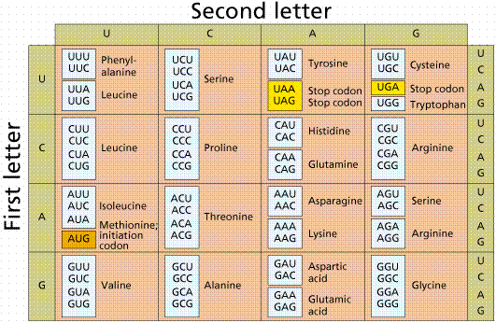
Translation
- The written code (codons) on mRNA is “translated” into a specific amino acid sequence by ___________________ribosomes in the cytoplasm.
- A tRNA molecule is a small piece of RNA that has a specific amino acid attached to it.
- The tRNA also has a special sequence of 3 nucleotide bases known as an anticodon. ___________________
- There is at least one type of tRNA for each of the 20 amino acids.
- As the correct amino acids are brought to the ribosome by the tRNAs, they are joined together to ______________________________________that the original DNA coded for.
- Note: there is ______________________________________for each amino acid.
The steps of translation:
- The mRNA molecule moves through a pore in the nuclear envelope and in to the cytoplasm. It joins with a ribosome and is ___________________translated one amino acid at a time.
- ___________________the first codon on any mRNA molecule is called the Initiator. This codon is always AUG which codes for the amino acid methionine. This is the message to start translation.
- ___________________: The ribosome’s job is to position the tRNA molecule onto the matching mRNA molecule. This makes it possible for a bond to be formed between the amino acids attached to the tRNA molecules. These amino acid chains make up the protein and an ___________________ catalyzes this reaction
- The first tRNA leaves, the ribosome moves over one codon, and another tRNA brings in the next amino acid. Another .bond is formed that the process continues for the length of the mRNA strand.
- ___________________: The last codon on any mRNA molecule is called the Terminator codon, which is a message to STOP translation. The codon will be either UAA, UAG, or UGA. None of these have a matching tRNA anticodon, so when no more tRNA’s attach, the ribosome, protein, and mRNA detach from each other.

A Bad Night at the Theatre
Question: What if something goes wrong during translation?
Answer: ___________________
- A ___________________ in the nucleotide sequence of DNA
- When the bases (letters) change, the wrong amino acids are used to make the protein.
- The protein ___________________be able to do its job.

There are 2 types of mutation:
- ______________________________________: a mutation of all or part of a chromosome. This usually involves MANY GENES, and therefore, MANY PROTEINS. Ex. Down’s syndrome.
- ______________________________________: a mutation that occurs within a gene at some point along a chromosome. This mutation is only a change of 1 or a few “letters” (nitrogenous bases)
- It usually only affects ___________________, and therefore ___________________. Ex. Sickle cell anemia

