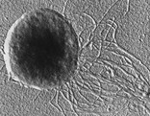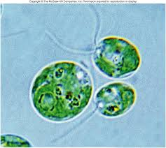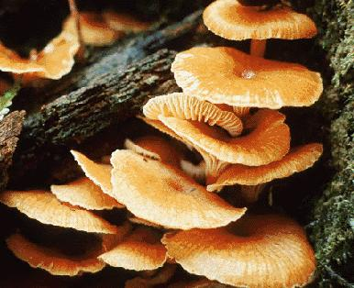
Venenivibrio stagnispumantis Protists: Many protists appear to Kingdom Fungi: Fungi cannot
From the Kingdom Eubacteria. Be both plant and animal. Like plants, manufacture their own food.
Feeds certain gases and specific they are green, and can create their They are called saprobes because
temperatures to obtain energy, own food. However, like animals, they absorb their food through
growth and development they have moving body parts and are the soil. Includes yeast, rusts,
able to move around their molds, and mushrooms.
environments

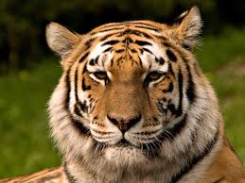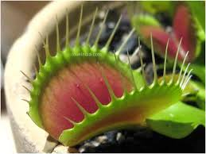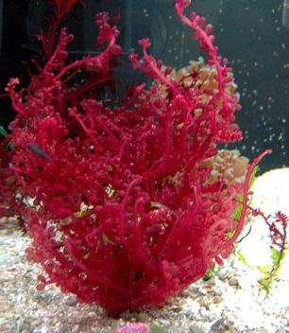
Kingdom Animalia Venus Flytrap- The Venus flytrap Red Algae: This macroscopic
(Dionaeamuscipula) is probably the marine algae contains
best known of the more than 600 chloroplasts, even though it
species of carnivorous plants, which doesn’t appear green.
absorb nutrients from prey rather
than through their roots.
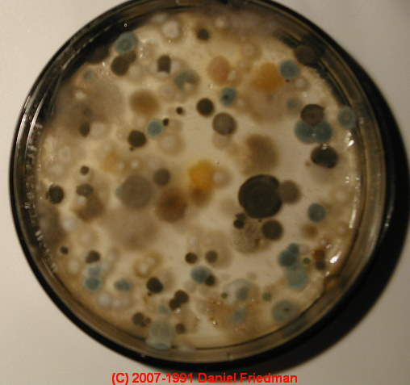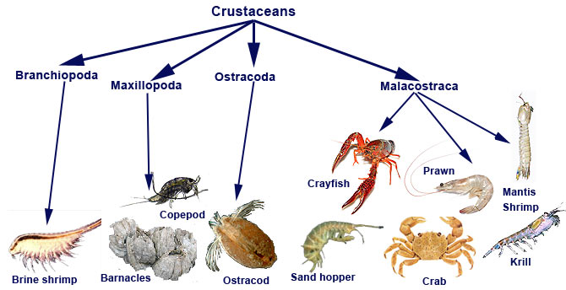
Typically, molds secrete enzymes, from the Crustaceans: Many crustaceans are scavengers, feeding on
hyphal tips. These enzymes degrade starch, scraps and dead creatures. Crabs, shrimps and prawns search
cellulose and lignin intosimpler substances for food mainly at night and hide in crevices by day. Some
which can be absorbed by the hyphae. In crabs and lobsters are active predators, seizing prey in powerful
this way molds play a major role in causing claws. Barnacles filter tiny creatures from the water using their
decomposition of organic material, enabling hairy legs. Woodlice munch on plant remains.
the recycling of nutrients throughout
ecosystems.

