CELL SIZE COMPARISON
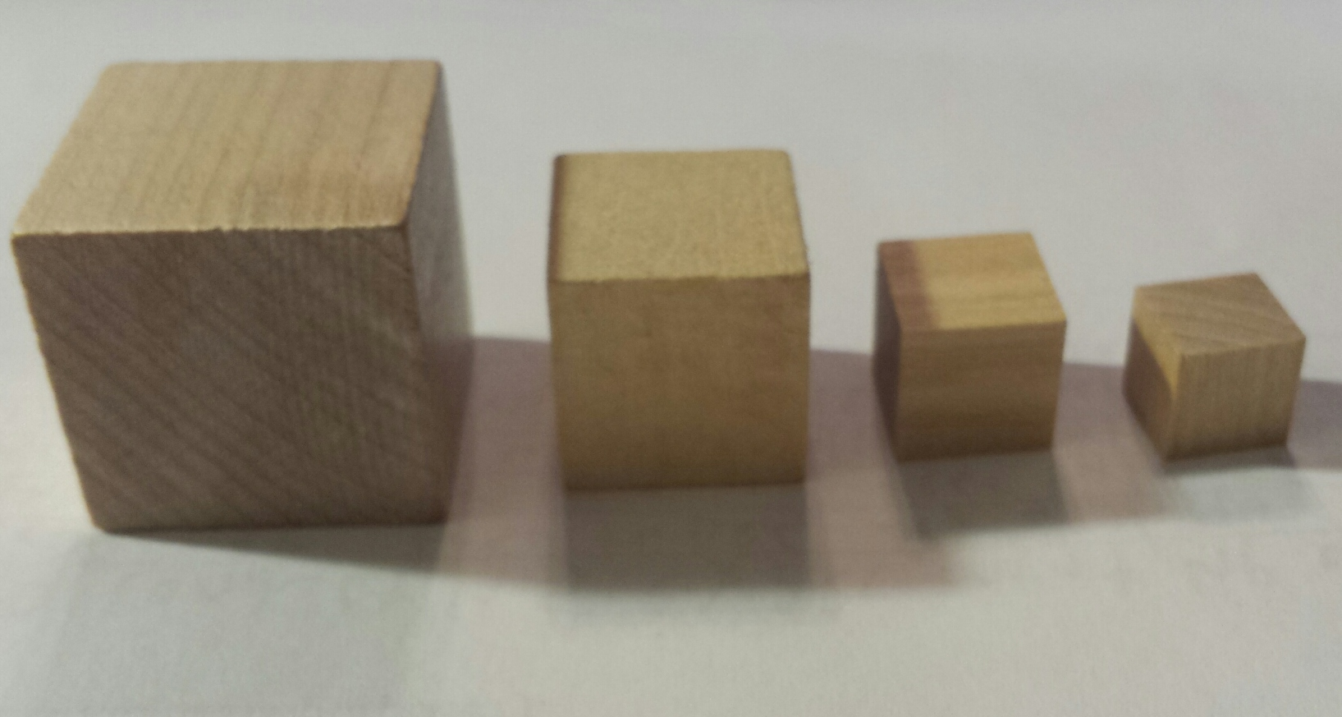
INTRODUCTION:
Cells are limited in how large they can be. This is because the surface area and volume ratio does not stay the same as their size increases. The larger a cell becomes, the less surface area it has compared with its volume. It is therefore less efficient for a large cell to pass materials in and out through the membrane, and to move materials throughout the cell.
In this lab, you will use cube models to represent cells. The dimension along one side will be doubled with each model. You will then calculate the surface area, volume, and the ratio between the two.
MATERIALS:
Wooden cubes
Rulers
PROCEDURE:
- Measure the sides of each cube in cm.
- Record the dimensions in the DATA TABLE below. The first one is done for you in the table.

***Note: If there is no number prior to the decimal point, always print a zero followed by the decimal point. See the example below.
DATA TABLE: The Comparison of Cell Sizes
Cell | Cell Dimension (cm) | Surface area  (cm²⁾ | Volume  (cm³⁾ | Ratio  Surface area to Volume
1 | 1.0 x 1.0 x 1.0
2
3
4
CALCULATIONS:
- Calculate the total surface area for each cell model by the following formula:
Surface area=(length x width) x 6 sides
Record the surface areas in the DATA TABLE.

- Calculate the volumes for each cell model by the following formula:
Volume=length x width x height
Record the volumes in the DATA TABLE.

- Calculate the surface area-to-volume ratio for each cell model by the following formal
Ratio= Surface area
Volume
Record the ratio values in the DATA TABLE.

****These ratios show how many times larger the surface area is as compared with the volume.
ANALYSIS:
- Graph surface area to volume measurements. Make sure you correctly label your graph!!!

- Describe in detail the trend(s) (compare surface area to volume) indicated on your graph.
____________________________________________________________________________________________________________________________________________________________________________________________________________________________________________________________

- Graph the length of the side of the cube by the surface area-to-volume ratio. Make sure you correctly label your graph!!!

- Describe in detail the trend(s) (compare Length of the side of cube to Surface area-to-volume ratio) indicated on your graph.
________________________________________________________________________________________________________________________________________________________________________ ____________________________________________________________________________________

CONCLUSION QUESTIONS:

- Which model has the smallest surface area? _____________________________________________
- Which model has the largest surface area? ______________________________________________
- Which model has the smallest volume? _________________________________________________
- Which model has the largest volume? __________________________________________________
- Which model has the smallest surface area to volume ratio? _________________________________
- Which model has the largest surface area to volume ratio? __________________________________
- As the cell grows larger, does the Surface area-to-volume ratio get larger, smaller, or remain the same? ____________________________________________________________________________________________________________________________________________________________________________________________

- Anything that the cell takes in, like oxygen or carbon dioxide, must go through the cell membrane on the outside of the cell. Which measurement best represents how much cell membrane the models have? ___________________________________________________________________________________

- The cell contents (organelles), like the nucleus and cytoplasm use oxygen and food while producing waste. Which measurement best represents the cell contents? ________________________________

- As the cell grows larger and gets more cellular content (organelles), will it need more or less cell membrane to survive? __________________________

- To maintain life, and carry-out cellular functions, materials must be able to move into and out of the cell. Also, material needs to be able to move within the cell. What might be the advantage of having a large surface area?
____________________________________________________________________________________________________________________________________________________________________________________

- What might be the disadvantage of having a large volume? ____________________________________________________________________________________________________________________________________________________________________________________________

- What happens to a cell if the surface area cannot support the volume of the cell? ____________________________________________________________________________________________________________________________________________________________________________________________

- Why can’t cells survive when the surface area-to-volume ratio becomes too small? ____________________________________________________________________________________________________________________________________________________________________________________________

- Which size cell has the greatest chance of survival? ____________________________________________
- What can cells do to increase their surface area-to-volume ratio?
________________________________________________________________________________________________________________________________________________________________________________________________________________________________________________________________________________________________________________________________________________________________________________________
