I. **Chromosomes, Mitosis and Meiosis**

A. You have many types of specialized cells in your body

1. Cells can be divided into two types:

a. **_______________________**  that make up most of your body tissues and organs.

**These cells undergo a special type of cell division called **_______________________**  in which each new cell has an exact copy of DNA as the parent cell.

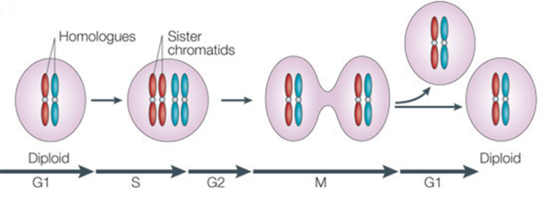

b. **_______________________** in your reproductive organs (the ovaries and testes)

1). Called **_______________________**, which form the egg and sperm cells.

2). Gametes contain the **____________** that will be passed to offspring in **_______________________**

  B. Each species has characteristic number of chromosomes per cell.

Ex. Humans have 46 or 23 pairs of chromosomes

Dogs have 78 or 39 pairs of chromosomes

Donkeys have 62 or 31 pairs of chromosomes.

  ***Complexity of an organism is not determined by the number of chromosomes

***Organisms differ from each other because of way genes are **_______________________**, not because they have **_______________________ _______________________**.

So, now you know!

Your cells have body and sex chromosomes depending on the cells they are found in!

A. Your body cells have **_________ pairs of _______________________ chromosomes**

In other words, you have two pairs (diploid) of chromosomes in each body cell- one from **_______________________** and one from **_______________________**

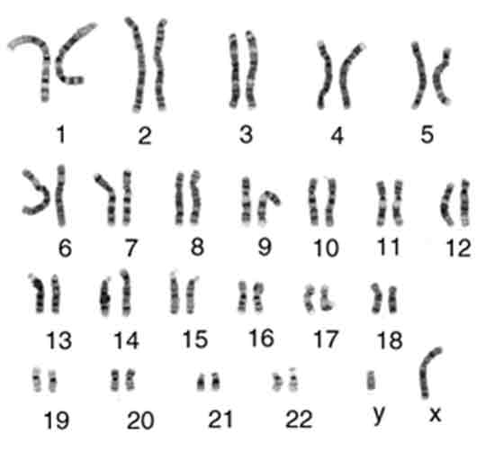

Therefore, you have 22 homologous chromosomes in your body cells.

a. Each homolog is very similar to each other

- **same length** and **carry same genes**

**_______________________ _________________**- one pair (**_______________________**) of non-homologous chromosomes

1. Directly control development of **sexual_______________________ characteristics**

2. Very different in humans (not homologous)

a. **____________ chromosome- female**

b. **____________-chromosome- male**

Sexual reproduction involves fusion of sperm and egg and is called**_______________________**

  a. results in **genetic_______________________** of both parents

Remember: **Egg** and **sperm** only have **________ usual number of chromosomes** (haploid). Fertilization results in a ____________________________ cell.

**Review:** Diploid and Haploid cells

  a. **Body cells** are**_______________________** (two copies of each chromosome)

  b. **Sperm and egg** are **_______________________** (have one copy of each chromosome)

Maintaining the correct number of chromosomes is important to survival of organisms

**Sex Cells** undergo process of **_______________________**  to form **sperm and eggs.**

  Meiosis differs from mitosis in significant ways.

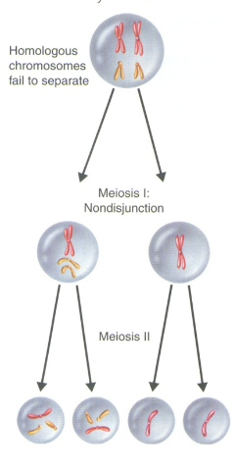



II. Mendel and Heredity

A. Gregor **____________________** laid the groundwork for genetics

1. **____________________** are distinguishing characteristics that are inherited.

2. **____________________** is the study of **biological ____________________ patterns** and variation.

3. Gregor Mendel showed that traits are inherited as **____________________________________.**

4. Many in Mendel’s day thought traits were blended.

B. Mendel’s data revealed **____________________ of inheritance**

1. Mendel studied plant variation in a monastery garden

2. Mendel made three key decisions in his experiments

a. **Control over breeding**

b. Use of**____________________**plants

c. Observation of “**either- or**” traits (only appear two alternate forms)

3. Experimental design

a. Mendel chose **____________________**because reproduce quickly and could control how they mate

b. Crossed purebred white-flowered with purebred purple-flowered pea plants.

1). Called **parental**, or **____________________**

2). Resulting plants (first filial or **____________________**) all had purple flowers

c. Allowed F1 generation to self-pollinate

  1). Produced **____________________**that had both plants with purple and white flowers)

2). Trait for white had been “hidden”, it did not disappear.

d. He began to observe **patterns**- Each cross yielded similar ratios in F2 generation (**3/4 had purple, and 1/4 white**)

  4. Mendel made three important conclusions

a. **Traits are inherited as discrete units** (explained why individual traits persisted without being blended or diluted over successive generations)

  b. Two other key conclusions collectively called the **________________________________________**

1). Organisms **inherit two copies** of each **___________________**, one from each parent

  2). **Organisms donate only __________________copy** of each gene in their gametes

**\*\*Remember:** two copies of each gene segregate, or separate, during gamete formation

Segregation Aa

**Aa represents the two copies of genes an individual received from mom and dad (one from each). They are able to donate either an A or an a to their offspring**

III. Traits, Genes, and Alleles

A. The **same gene** can have **many versions**

1. **__________________**- a “piece” of DNA that provides a set of instructions to a cell to make a certain **protein**.

1. Most genes exist in many forms (called **____________________**)
2. You have**____________________**alleles for each gene`

2. **____________________**- means two of same allele

3. **____________________**- two different alleles

B. Genes influence the development of traits

1. **____________________** is all the organisms genetic material

2. **____________________**- refers to genetic makeup of a specific set of genes

3. **____________________**- physical characteristics of organism (wrinkled or round seeds)

C. Dominant and Recessive Alleles

1. **Dominant alleles**- allele that is expressed when two different alleles or two dominant alleles are present (use capital letter to represent)

2. **Recessive alleles**- only expressed if have two copies of recessive present (use small-case letter to represent)

3. **Homozygous dominant =­_____**

4. **Heterozygous = _______**

5. **Homozygous recessive = ______**

D. Alleles and Phenotypes

1. Both homozygous dominant and heterozygous genotypes yield a dominant phenotype.

2. Most traits occur in a **range** and do not follow simple dominant-recessive patterns

V. Traits and Probability

A. **Punnett squares** illustrate genetic crosses

1. Used to **predict possible genotypes** resulting from a cross

a. Axes of grid represent possible **gamete** genotypes of each parents

b. Boxes show **genotypes** of **offspring**

c. Can determine **ratio** of genotypes in each generation

B. **____________________ cross involves one trait**

1. **Homozygous dominant X Homozygous recessive**

2. **Heterozygous X Heterozygous**

3. **Heterozygous X Homozygous recessive**

C. **____________________**- a cross between organism with an unknown genotype and an organism with a recessive phenotype

D. **____________________**cross involves two traits

1. Mendel also conducted dihybrid crosses- wondered if both traits would always appear together or if they would be expressed **________________________________________** of each other

2. Mendel discovered phenotypic ratio in F2 generation as always **____________________** regardless of combination traits he used when parents are heterozygous for both traits.

E. Heredity patterns can be calculated with probability

1. **____________________** - the likelihood that a particular event will happen

2. Probability applies to random events such as **meiosis** and **fertilization**

VI. Meiosis and Genetic Variation

A. **Sexual reproduction** creates **____________________ gene combinations**

1. Sexual reproduction creates unique combination of genes

a.**____________________assortment** of chromosomes in meiosis

b. **random fertilization of gametes**

2. 223 possible sperm or egg cells combinations produced

223 X 223 = about 70 trillion different combinations of chromosomes

B. **________________________________________**during meiosis increases genetic diversity

1. **crossing over** - exchange of chromosome segments between homologous chromosomes during Prophase I of Meiosis I

2. Results in **new combination of genes**

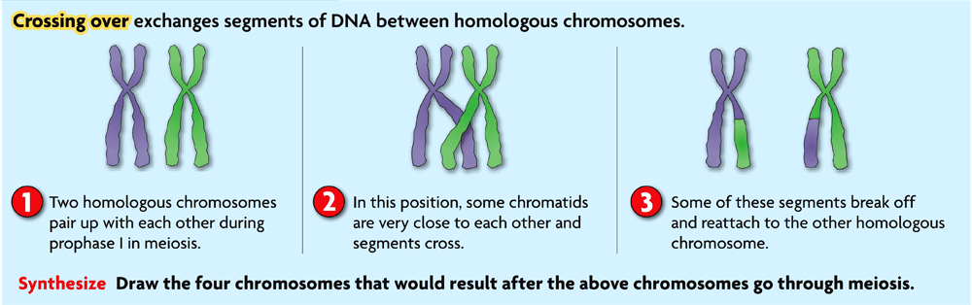

C. **Linked genes** - genes located on the same chromosome inherited together.

1. **Closer together** they are**____________________**chance of inheriting together

2. If **genes far apart**, **crossing-over may separate them**

3. **Gene linkage** used to build **______________________________________**of many species