Errors=mutations

1. Mutations can occur ______________________ or through __________________ factors.
   1. Environmental ______________________ include some ______________________ (food additives, pesticides, plastics) and __________________________ (xrays to UV light)
2. A ____________________________ is a change of one or more __________________________ in a single gene. There are three types
   1. Addition
   2. Deletion
   3. Substitution

GENE MUTATIONS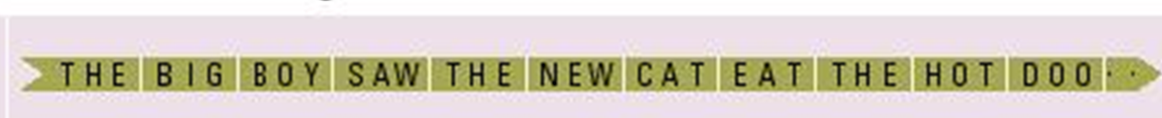

1. Deletion: one nucleotide base is left out. All of the amino acids after a deletion will be wrong, so ____________________ and ____________________ of protein are altered. ____________________

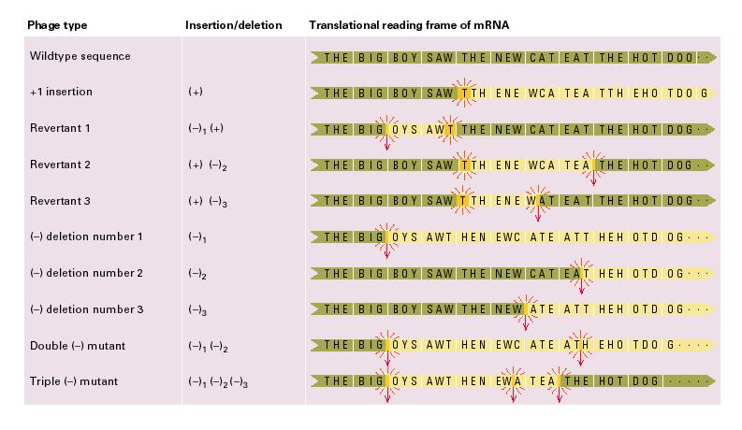

1. Addition: One extra nucleotide base is added. This will also change the entire amino acid sequence of the protein so ___________________ and _______________ of protein are altered. ___________________

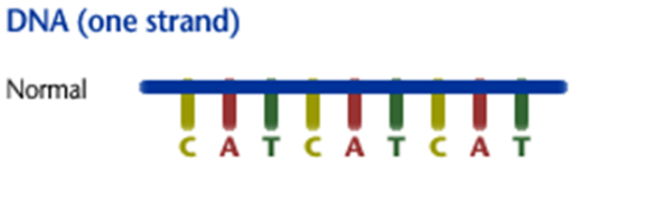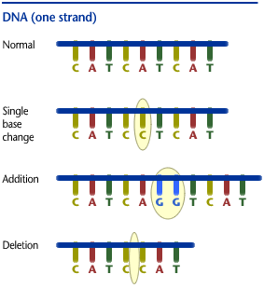

1. Substitution: When single bases or short pieces are replaced with one another.

Example: Sickle-Cell Anemia, only one nucleotide base is switched. This causes only 1 amino acid to change, but it an important one.

This type of mutation is usually ________________________________________ as the 1st two. It just depends on which amino acid is affected; as several nucleotide sequences may code for same amino acid.



1. _________________________ mutations: a mutation of ___________________________ of a chromosome. These affect ___________________________________.
   1. Example 1: _____________________________ where one part of a chromosome changes places with another. This can cause extra pieces, missing pieces, or the exchange of pieces of chromosomes. Examples: Cri du Chat __________________________________________________
   2. Example 2;______________________________ extra chromosomes or missing chromosomes due to mistakes during mitosis or meiosis (cell division)

Examples: Down Syndrome ___________________, Klinefelter Syndrome________________________, Turner’s Syndrome _________________________

**Current Technology and News**

Recombinant DNA

Definition: ___________________________________________________________________________

1. Gene __________________________-: add an extra copy of gene (cows with huge teats to make double the mile) or deleting genes (removing the rotting hormone from tomatoes)
2. Gene __________________________: repairing a gene (as in gene therapy)
3. Gene __________________________: inserting genes from a different species to give a new function (as in making goats with spider proteins in their milk or making bacteria that create human insulin).

Transgenic Organism-Organisms who have the DNA of other organisms inserted in them, recombining their DNA.

What is a GMO?

-result of technology that has altered the DNA of living organisms (animals, plants or bacteria)

-other terms that mean the same thing

-genetically engineered, transgenic, Recombinant DNA (rDNA technology.

GM vs. Selective breading

___________________

-slow

-imprecise

-modification of genes that naturally occur in the organism

__________________

-very fast

-precise

-can introduce genes into an organism that would not occur naturally!

Why do it?

* Rice- not high in essential nutrients
  + Modification:
* + daffodil genes and a bacterium = beta-carotene content drastically increased
* + genes from a french bean = double the iron content.
* Tomatoes- Introduce genes to increase shelf life.
* Other Applications
* Potato - modified to produce a beetle killing toxin
* Yellow squash – modified to contain to viral genes that resistant the most common viral diseases
* Develop foods that contain vaccines and antibodies that offer valuable protection against diseases such as cholera, hepatitis, and malaria
* Canola – modified to resist one type of herbicide or pesticide

**Benefits of Genetic Engineering   
and Modifying**

* ___________________________________ crops, more efficient use of land
* Can save money and promote higher profits
* _________________ shelf life, less waste
* Example/ Tomatoes from genetically modified seeds stay fresh longer.
* ______________________ taste and quality
* Reduced maturation time

**Benefits of Genetic Engineering and Modifying Genes**

1. Increased and improved nutrients and stress tolerance
   1. A single gene genetically engineered into cauliflower can ____________________________ of beta-carotene 100 times.
   2. A gene can be implanted into a soybean upgrading the soy protein to a quality equal to that of milk.
   3. Corn can be modified to contain its two limiting amino acids, lysine or tryptophan
2. Improved ____________________________________________________ or illness
   1. Foods can be enhanced with phytochemicals that help maintain health and reduce the risks of chronic disease.
3. Improved crop resistance to disease, pests, weeds and herbicides
4. _______________________________________________ and growing techniques
   1. “Individuals allergic to milk may be able to buy milk that has been treated with the lactase enzyme

Creating decaffeinated coffee beans are in a process of research.

Who Uses this technology? _________________________________________________________

**Risks associated with Genetic Modification**

**1. ________________________________**

* Potential human health implications.
* Cancer, liver, kidney damage in studies with rats
* Potential environmental impact.
* **Out-crossing**
* Inevitable out-crossing of transgenic plants with naturally occurring ones.
* Creation of super-weeds
* Creation of biological weapons.

**2. Access and __________________________________________________**

* Domination of world food production by a few companies and developing countries.

**3. ___________________________________**

* “Playing God”
* Tampering with nature by mixing genes

among species.

**4. _________________________________________**

* Not mandatory in some countries (e.g., Canada and the United States).
* Mixing GM crops with non-GM confounds labeling attempts.

**5. Society**

* New advances may be _______________________________ to the interests of rich countries.

(Human Genome Project Information (2003), http://www.ornl.gov/sci/techresources/Human_Genome/elsi/gmfood.shtml